Question 1

HPA

* First I have cloned the given repo
* Then I built docker image
* Then performed docker push

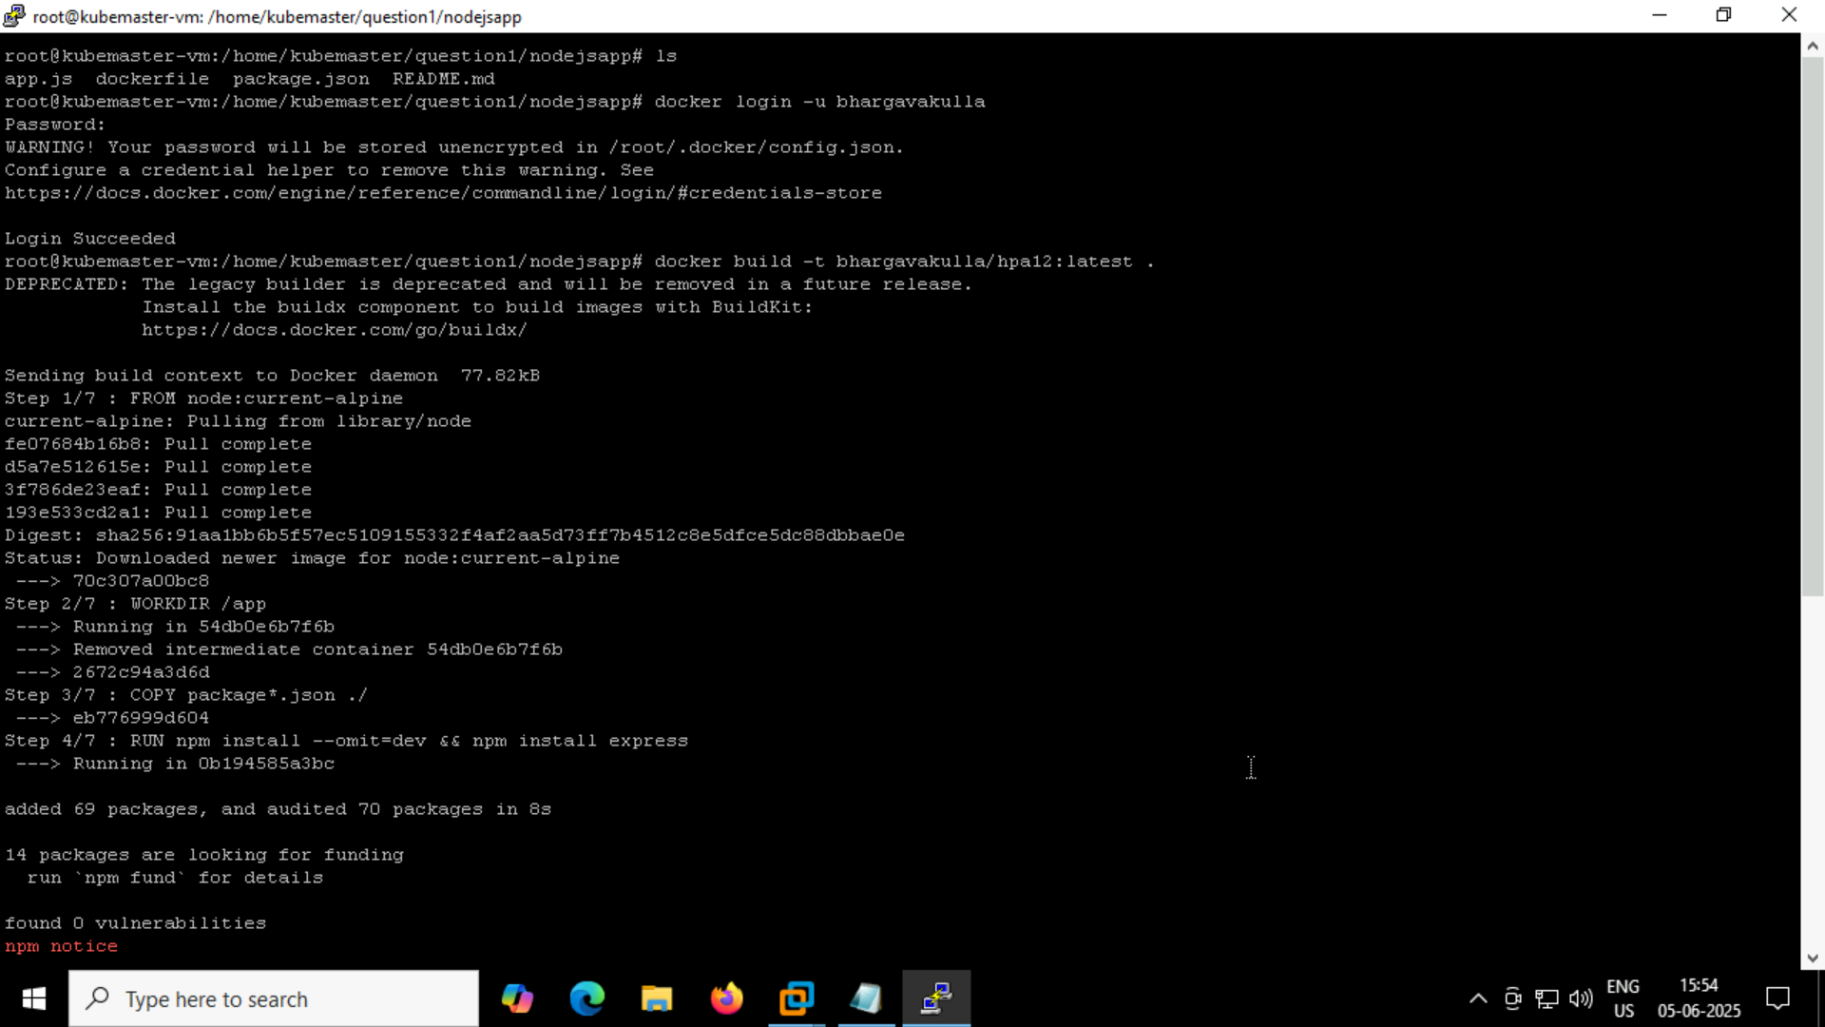

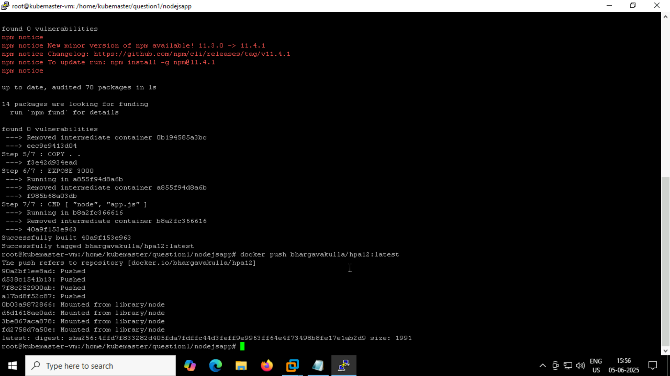

Next created deployment.yaml, service.yaml, hpa.yaml files and applied







Service.yaml

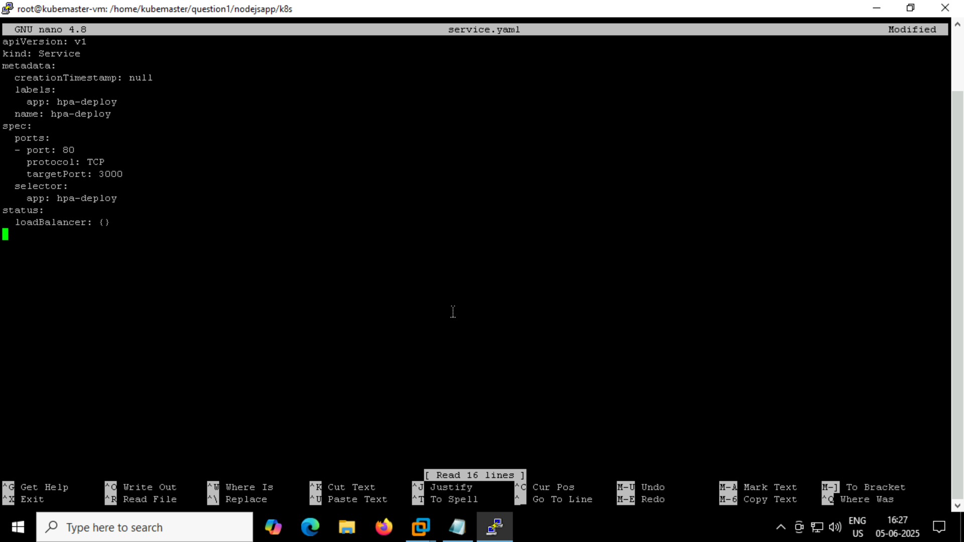

Hpa.yaml

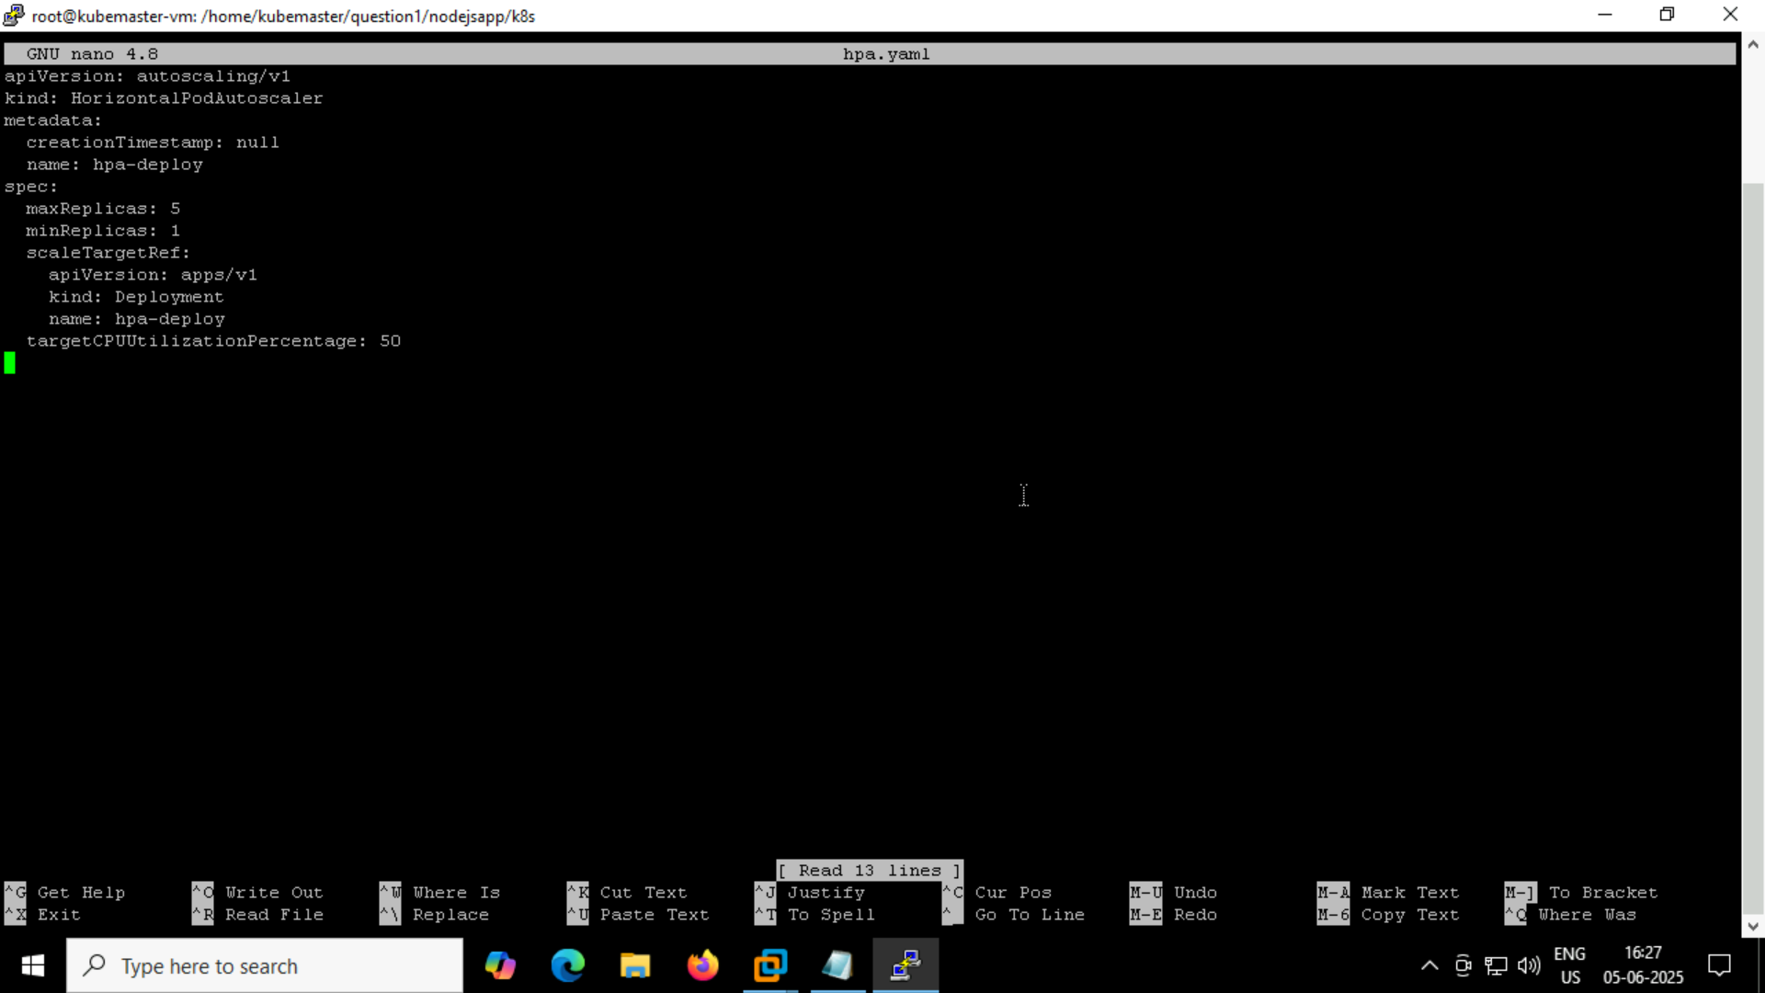

Deployment.yaml

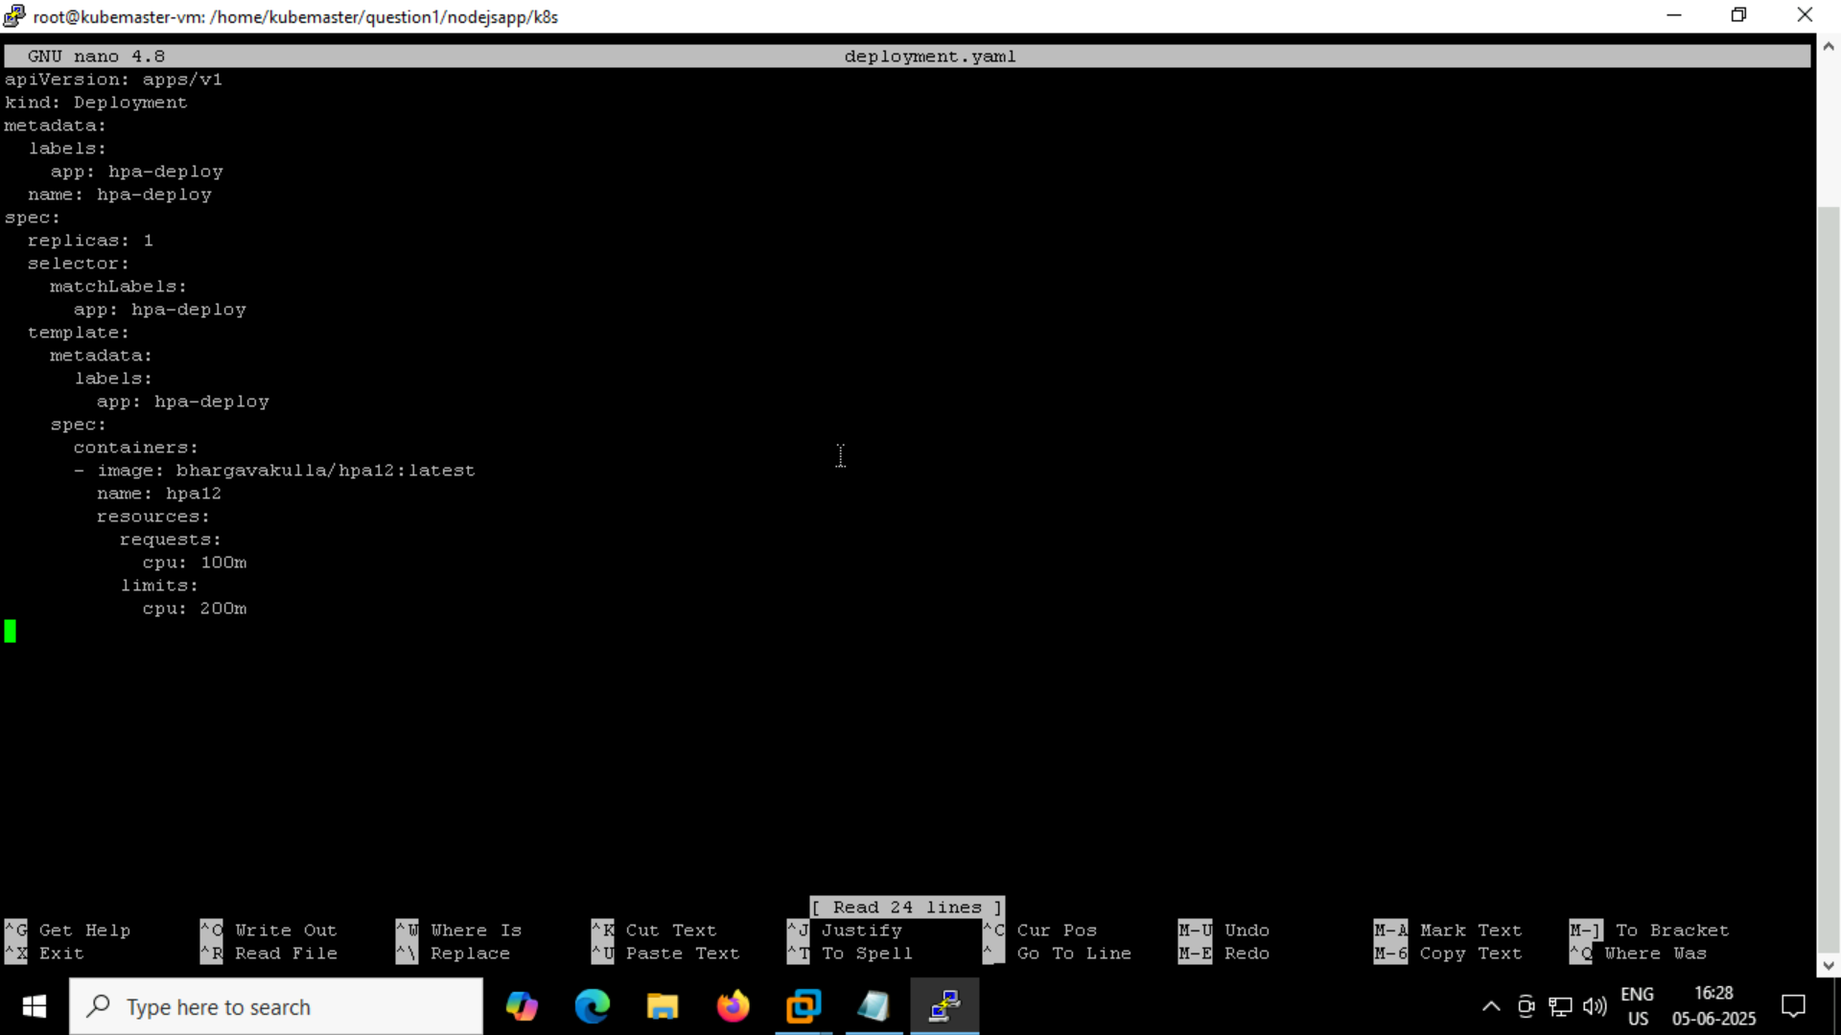

After modification of deployment.yaml I re-applied it



So the pod is running

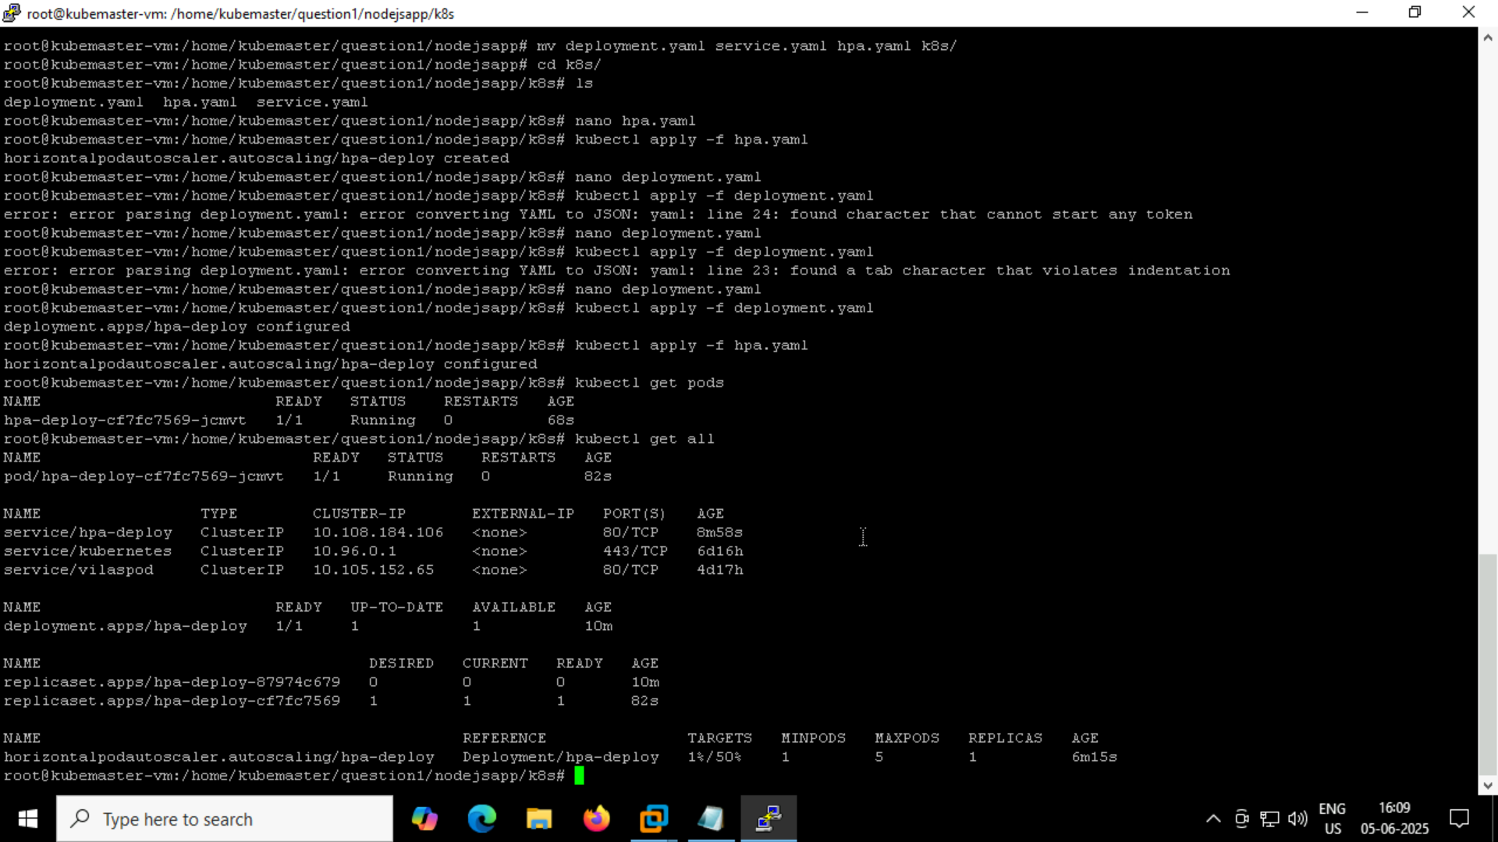

Now I have created another folder stress-pod inside that I have created deploy.yaml

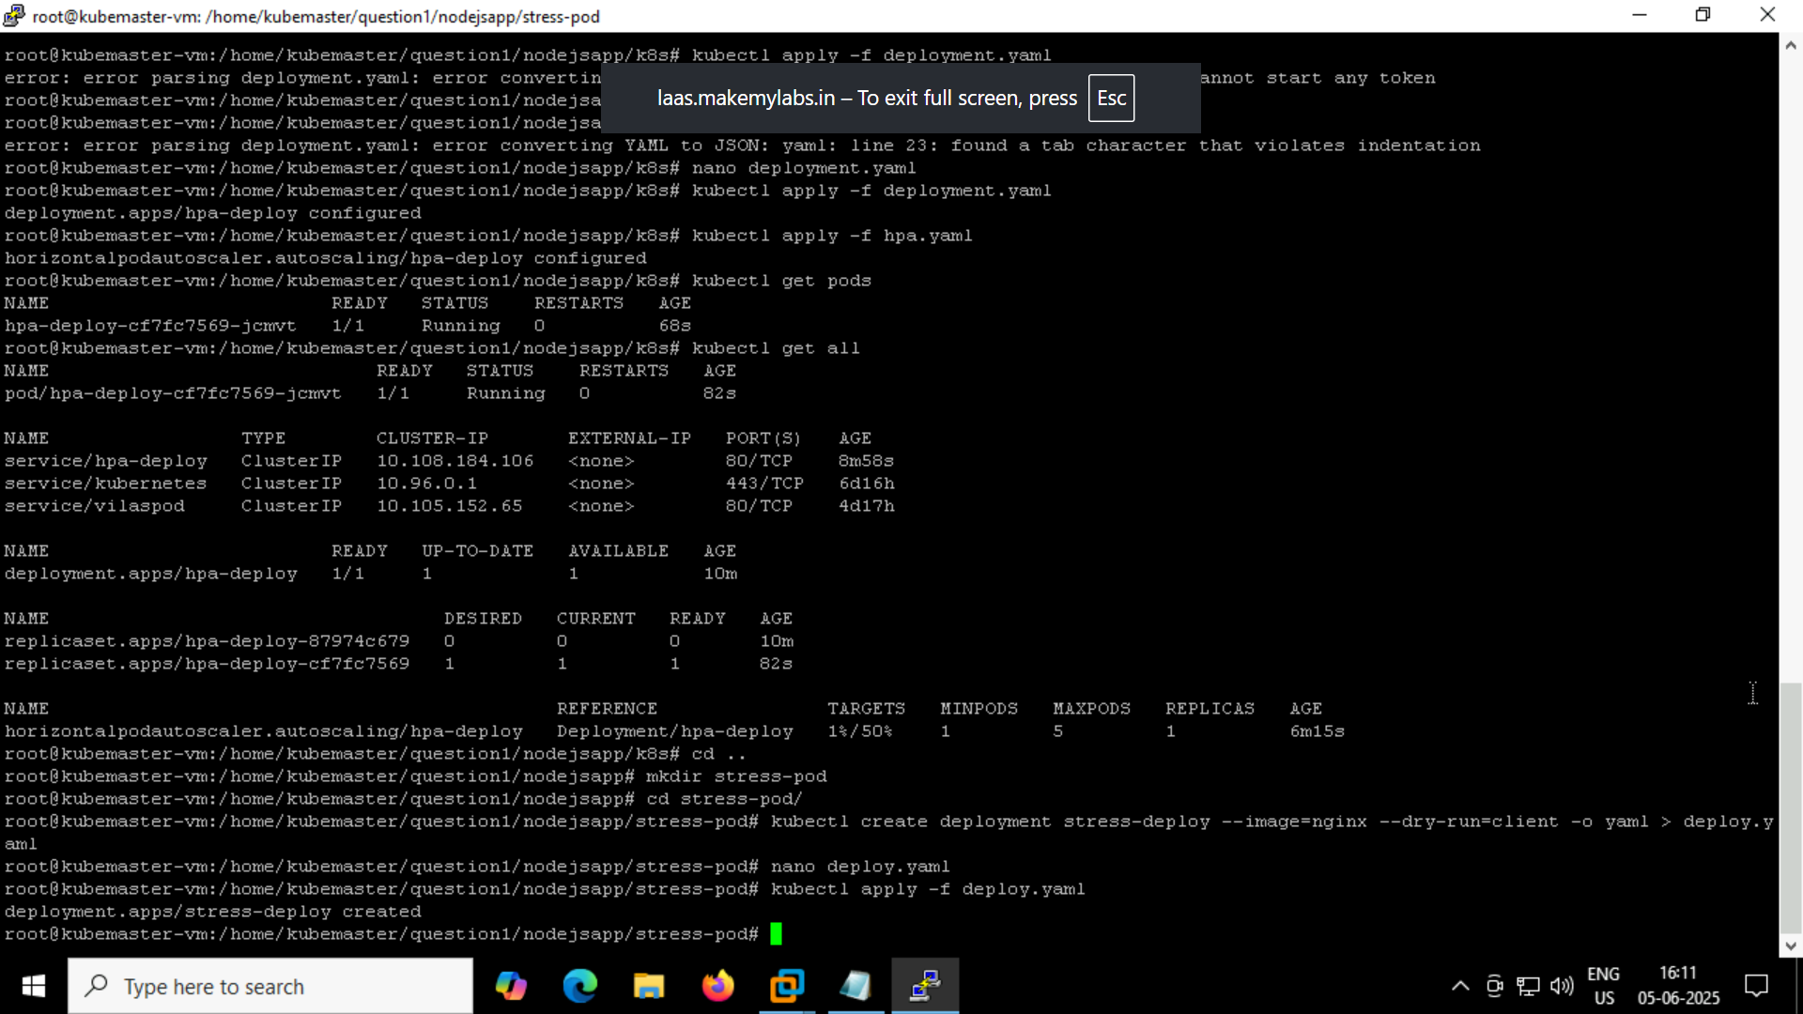

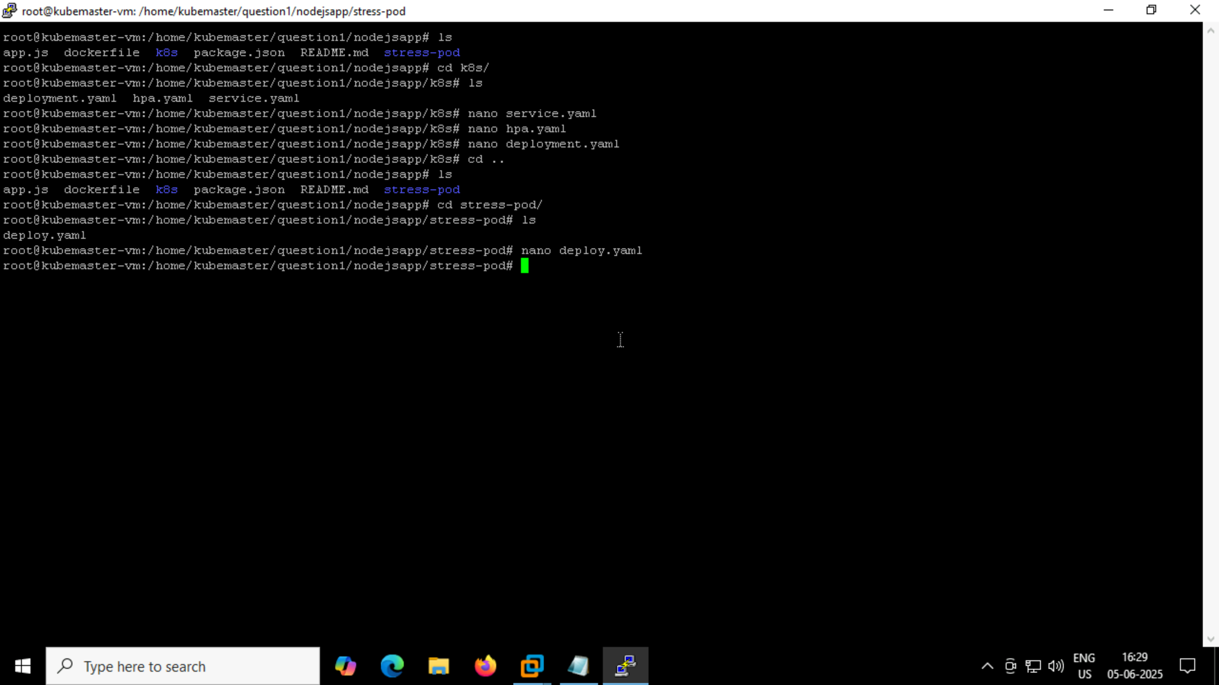

Deploy.yaml

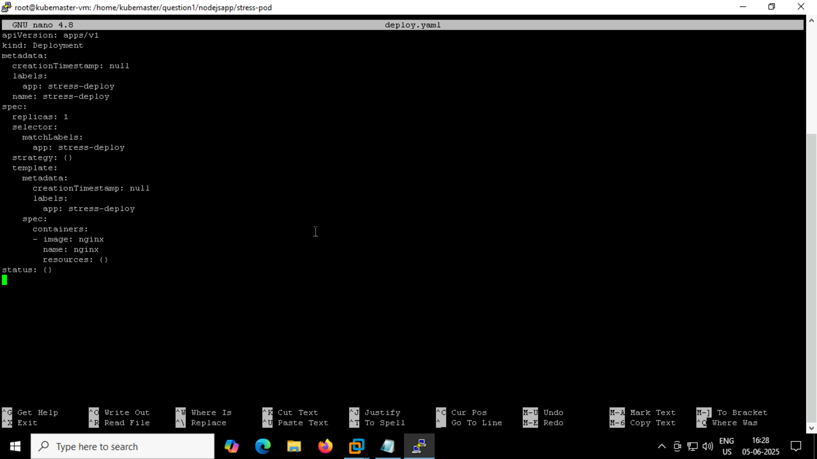

After that I have applied stress on the newly created stress-deploy pod



So when the cpu is more than 50% pods is created

Final validation output

